 Pegasys
[Copy From]

- One of the many features in Pegasys is a component called “Copy From.” By using this method, users can replicate information from a previous document and place it into the new document. Usually Copy From is used when the user only wants to make small adjustments from the preexisting document, such as repeats orders, recurring monthly statements, and training orders.

Figure 1
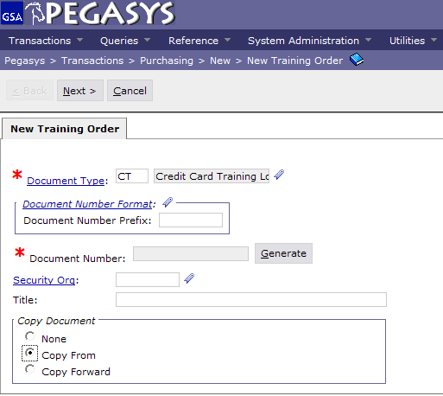
Enter “Document Type”
Click Generate
Check “Copy From”

Figure 1

- In the Document Type box, type in the document type for your new order. (Step 1)
- Click Tab to populate the next box.
- Click Generate to get the document number. (Step 2)
  - The screen will refresh and bring you back to the same screen with your new document number.
- Check the Copy From box under the Copy Document subsection. (Step 3)
- After the screen refreshes, click Next in the upper left hand corner.

(OVER)

Figure 2
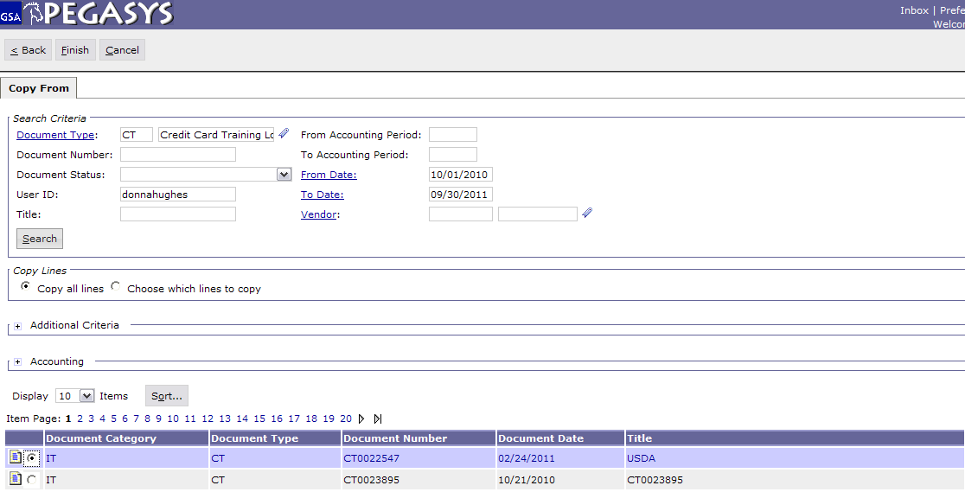
Enter “Document Type”
Click Search
Select the document to copy
Click Finish
2) Search by “Document Number, Login ID, Date Range”

Figure 2

- Enter in the Document Type to begin your search. (Step 1)
- To find a specific document that you want to copy from, there are a few search options to choose from. (Step 2)
  - Document Number- If the user knows this, only this search criteria is required
  - Login ID
Must use both to search using this method
  - Date Range
- Click Search after entering in search criteria options. (Step 3)
- When the search results are returned, select the document to copy from. (Step 4)
- Click Finish when you have selected the document to copy. (Step 5)

